1a)

i)

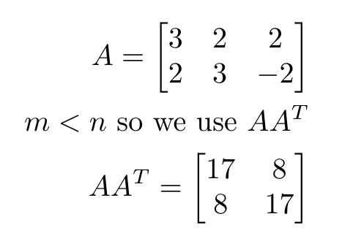

Next find eigenvalues of this matrix

You get $λ= 25, 9$

Find orthonormal eigenvectors

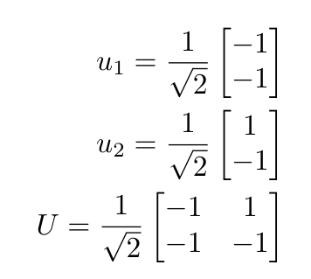

Now to find V

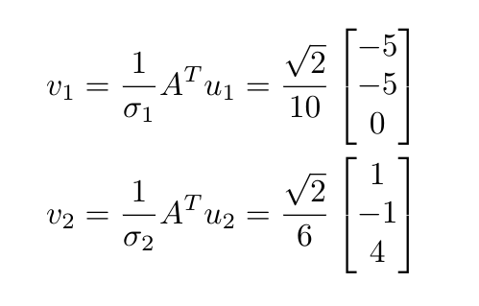

Need to extend this to get the third orthonormal vector. Can use cross product.

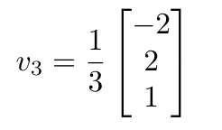

Put them together

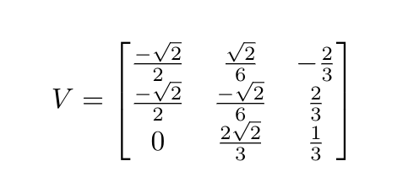

And S is just

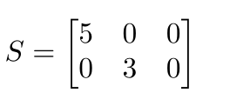

Has to be the right shape.

So A = USV^T

ii) 5 (largest singular value)

b)

i) Find eigenvalues in the normal way. Only get $λ=1$ with algebraic multiplicity 3.

Calculate null(A - $λI)$. Only get one vector so geometric multiplicity is 1.

ii) To find generalised eigenvectors do $(A - λI)v_{2} =v_{1}$ and $(A - λI)v_{3} =v_{2}$.

Normal eigenvector = [2 0 -1]^T.

Generalised eigenvectors = {[0 1 0]^T, [1 0 0]^T}

c) i)

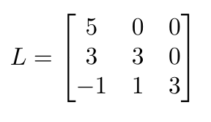

All the elements on the diagonal of L are positive so C is positive definite by Cholesky decomposition properties

ii)

This question is 28.3-3 in Introduction to Algorithms (CLRS). 😢

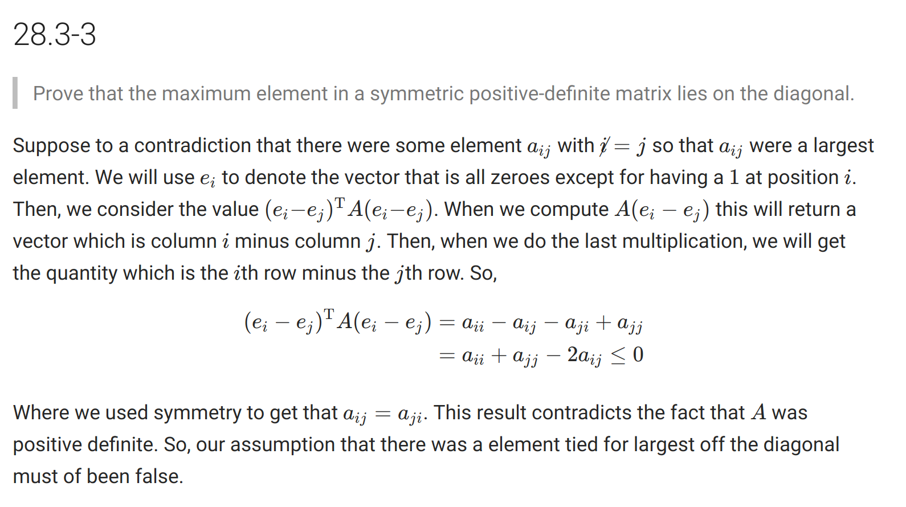

2a)

i) 308/99 * 12 = 112/3 = 37.3...

b)

i)

(I+M)Gn = Gn + MGn

= Gn + M - M2 + … (-1)nMn+1

= I - M + M2 + … + (-1)nMn + M - M2 + … (-1)nMn+1

= I + (-1)nMn+1

ii)

By the definition of convergence, in the metric space of matrices ∀ E > 0, d(Mn , O) < E for large enough n.

x

d(Mn, O) = ||Mn - O||

= ||Mn||

<= ||M||n (by the submultiplicative property)

= 0 as n -> infinity (||M|| < 1 and the sequence is geometric)

Hence, Mn -> O when ||M|| < 1.

iii)

(I + M)Gn = I + (-1)nMn+1 => (I + M)Ginfinity = I => Ginfinity = (I + M)-1

c)

S(x, y, z) = 2x + 2y + 2z // wth, look below for correct eqn

Under the constraint xyz = 1 we have S(x, y) = 2x + 2y + 2x-1y-1

∇S(x, y) = [2 - 2x-2y-1, 2 - 2x-1y-2]

Solve 2 - 2x-2y-1 = 0 and 2 - 2x-1y-2 = 0 to get a stationary point at x = y = 1.

Our Hessian matrix is

HS(x, y) = whatever

And HS(1, 1) is positive definite so we have a minimum at x = y = z = 1.

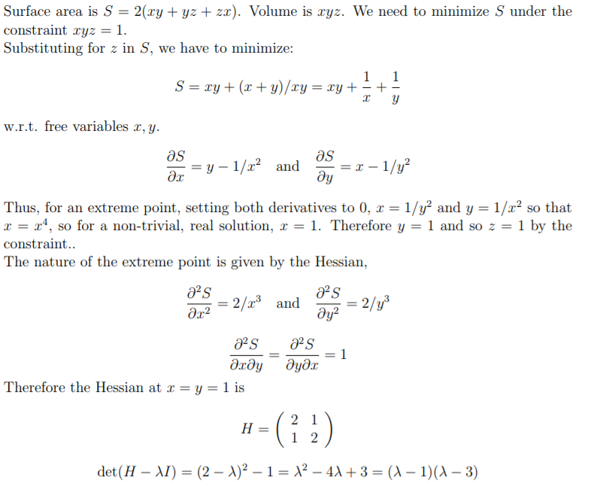

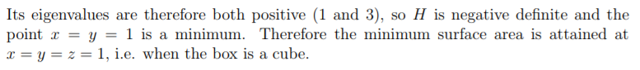

d)

Help

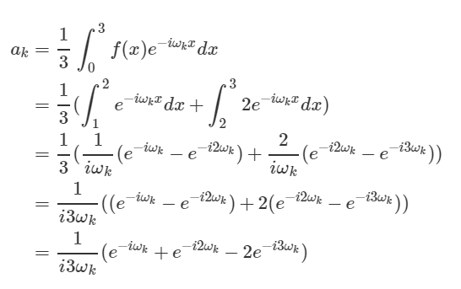

Wot even is this

Cba to simplify (lol)

Cba with life

This is what I got but it’s most likely wrong ^_^

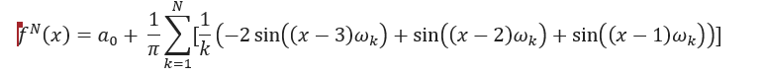a0 is 0